Part 1: Local Git Version Control
1. Objective
Part 1 of this assignment demonstrates the use of Git for local version control of a Student Task Management System. It covers creating a repository, tracking changes, making commits, creating a feature branch, developing a task status feature, and merging the feature into the main branch.
2. Tools Used
The following tools were used to complete Part 1:
- Git – Version control and repository management
- Git GUI – Graphical interface for Git operations
- Web Browser – Testing and viewing the web application
- Visual Studio Code – Code editor
3. Project:
The Student Task Management System consists of the following files:
- index.html – Defines the structure and content of the web application.
- style.css – Contains the styling and layout of the application.
- script.js – Handles task creation, validation, and task status functionality.
- README.md – Provides information about the project, its features, structure, and usage.
- .gitignore – Specifies files and folders that should not be tracked by Git.
Task 1 – Create the Initial Web Project
1. Initial Project Folder Structure:
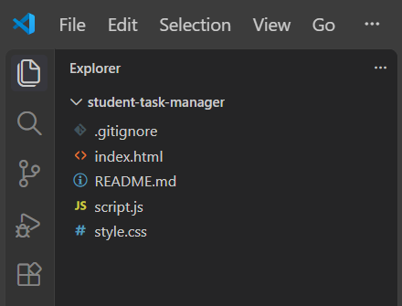
2. Initial Web Application Interface:

Task 2 – Create the Local Git Repository
3. Git GUI Repository Interface:
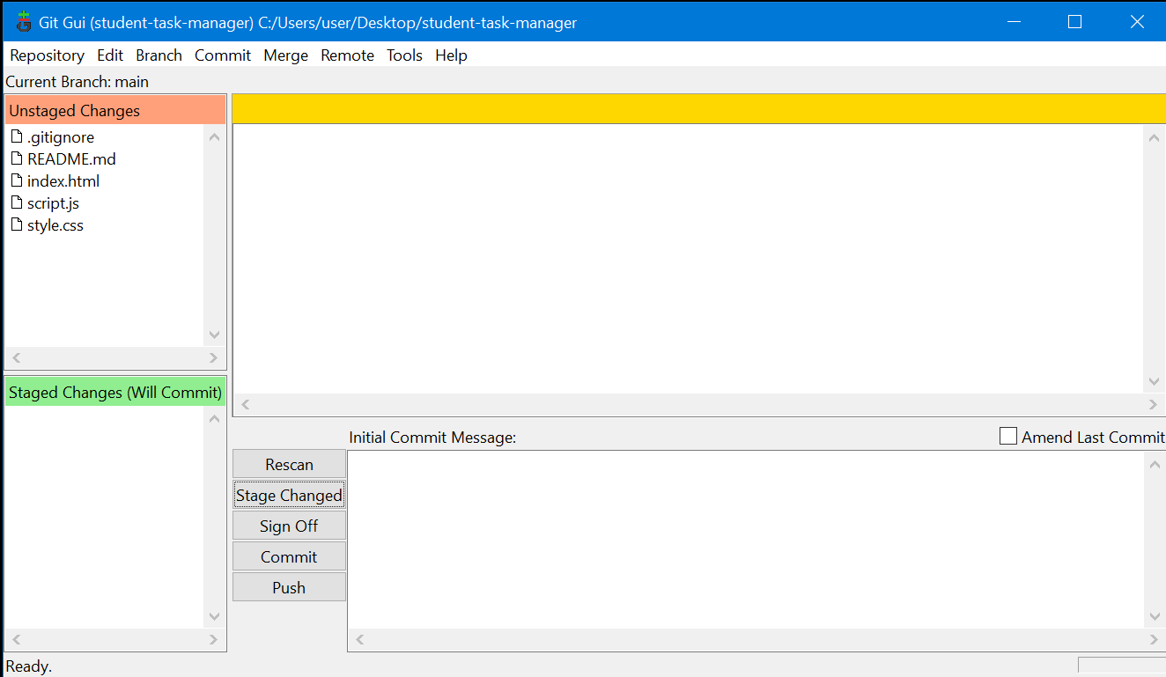
Task 3 – Stage and Commit the Initial Version
4. Staged Project Files:
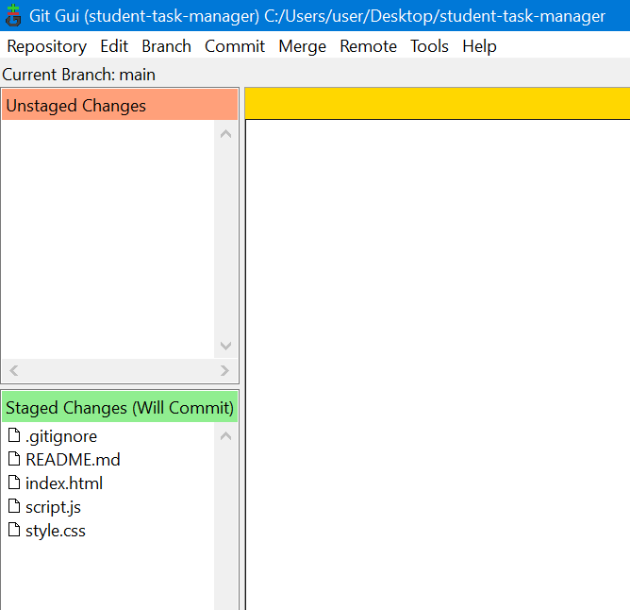
5. Initial Commit:
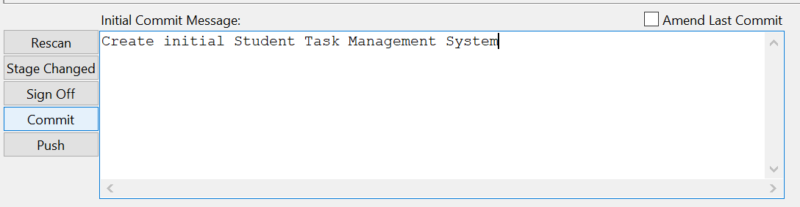

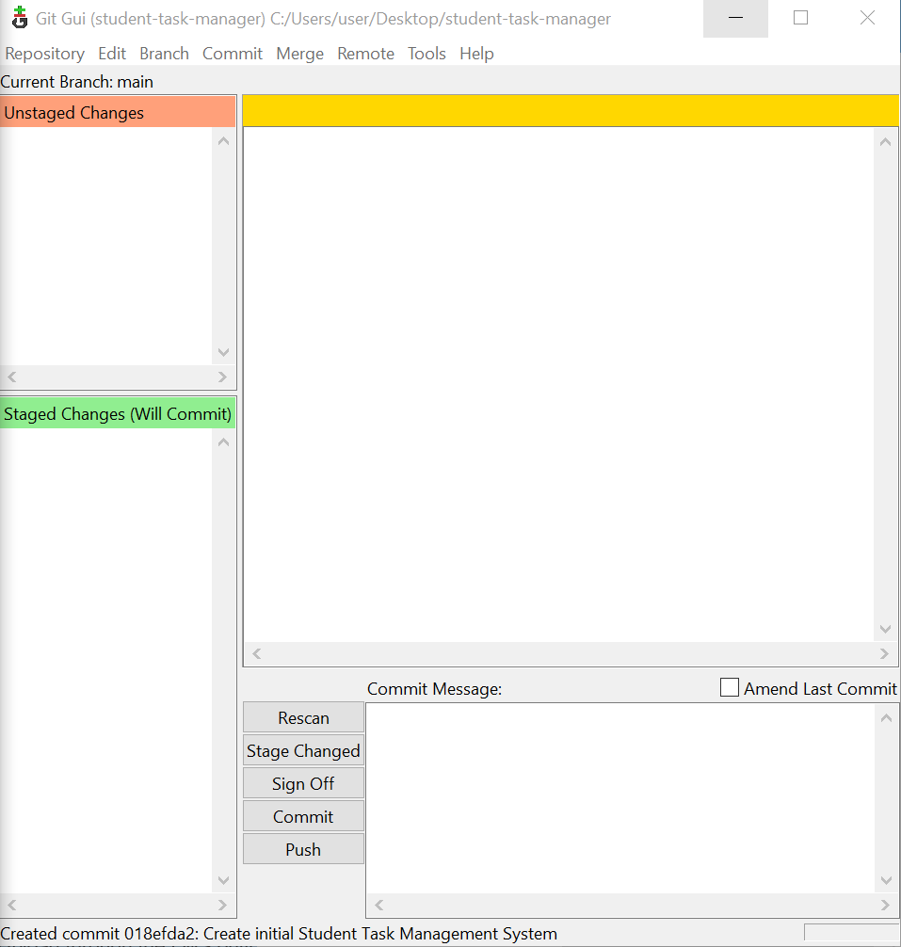
6. Git Commit History After Initial Commit:
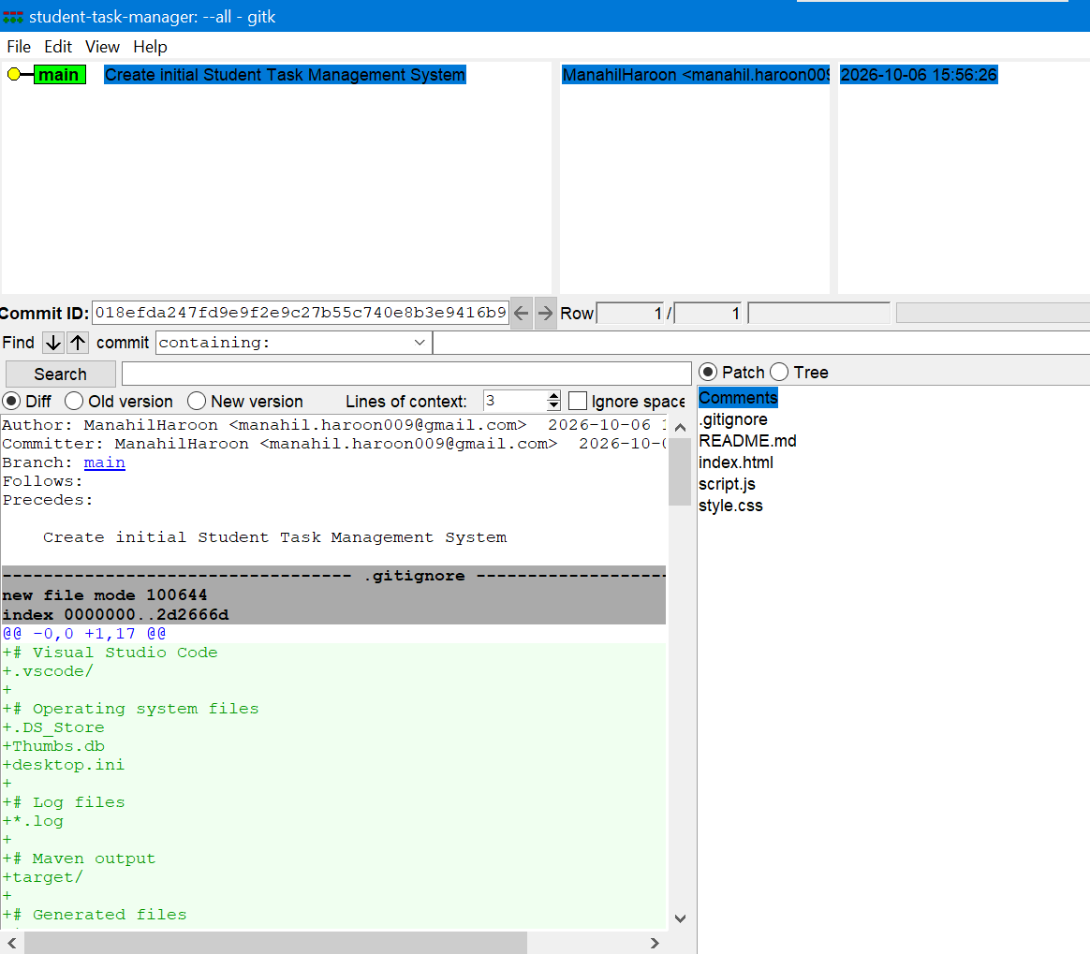
Task 4 – Create a Second Commit
7. Updated Webpage Heading:
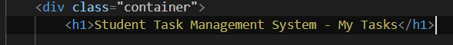
8. Git GUI Showing Changes After Code Modification:
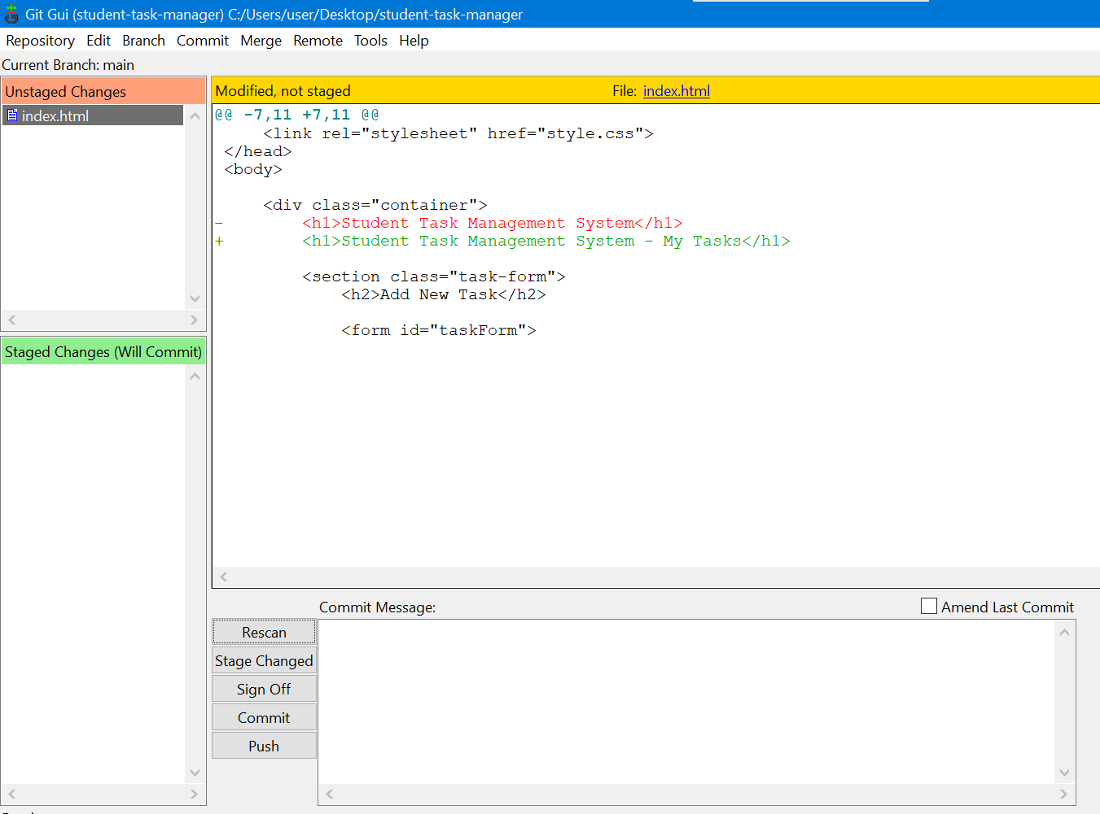
9. Staged Changes for the Second Commit:
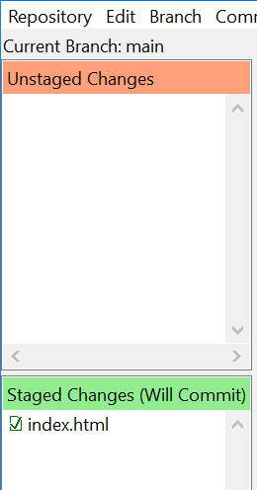
10. Second Commit:
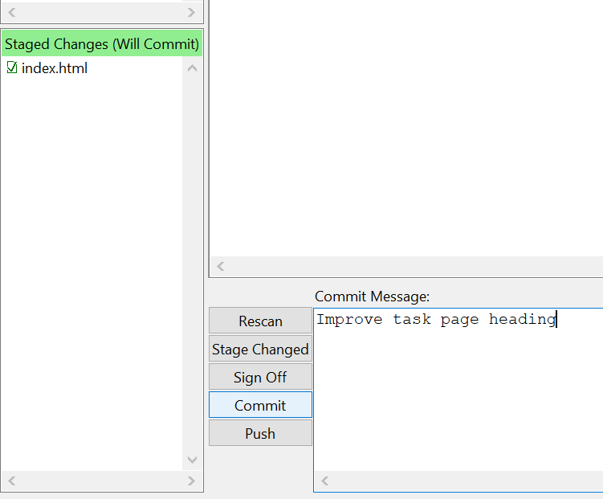
11. Git History Showing Successful Second Commit:
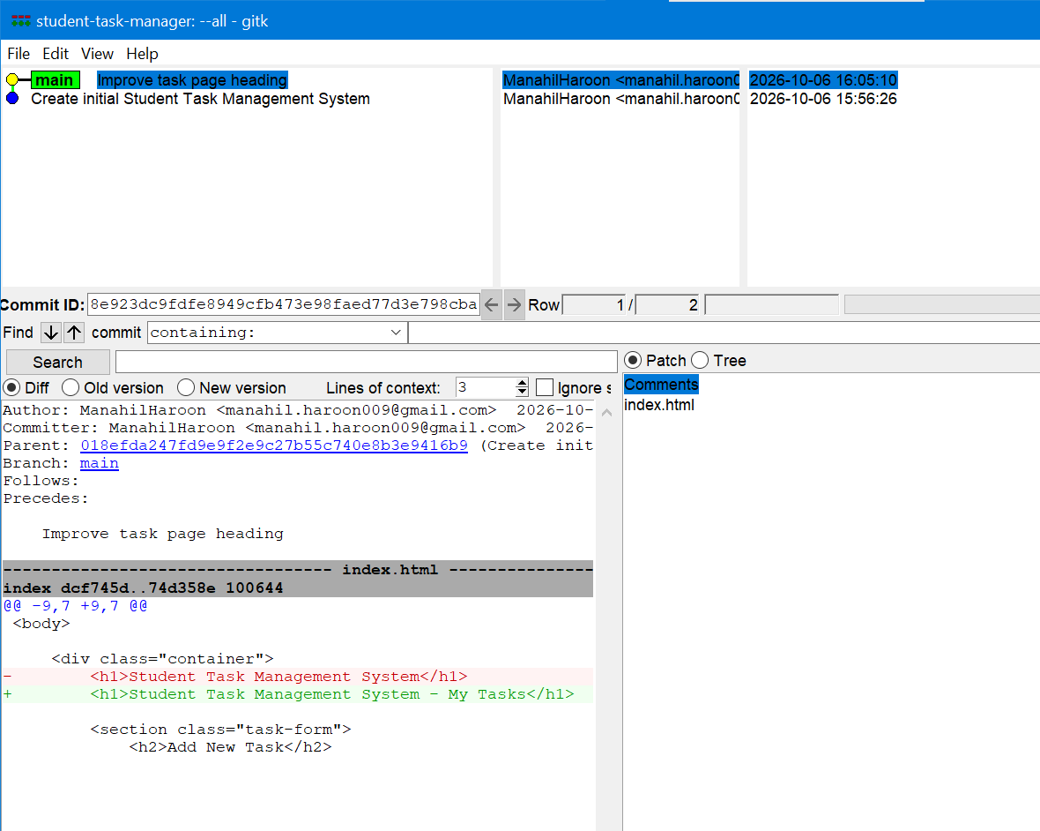
12. Updated Web Application:

Task 5 – Develop a Feature Branch
13. Creating The Feature Branch:
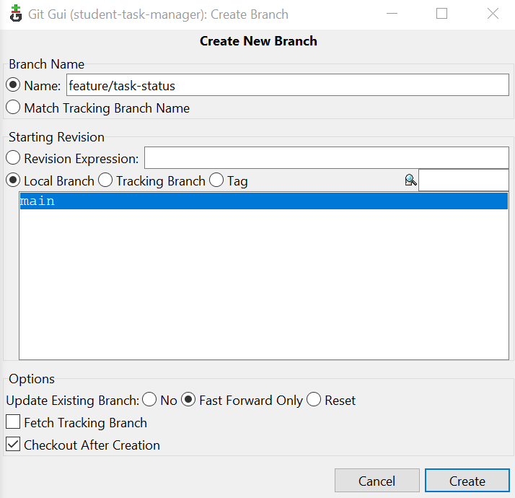
14. Feature Branch Successfully Created and Checked Out:
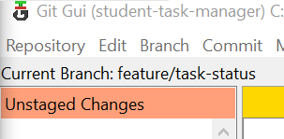
15. Task Status Selection Options:
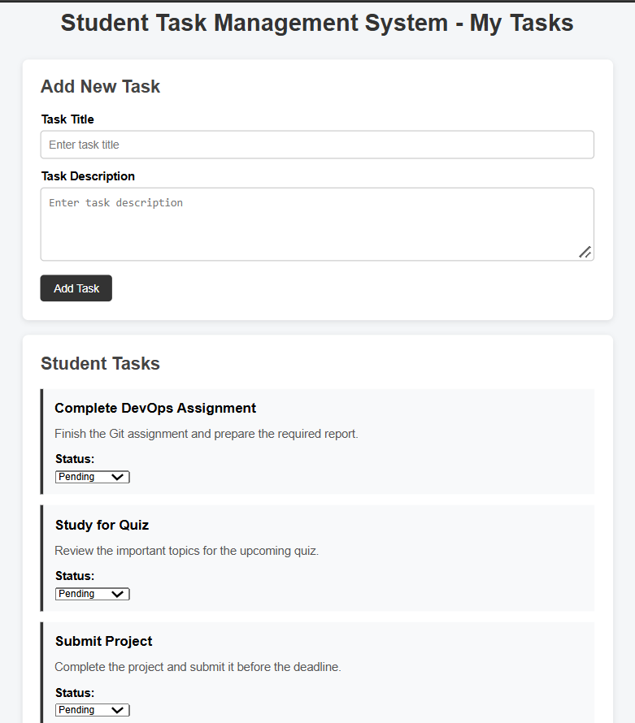
16. Unstaged Changes After Adding Task Status Feature:
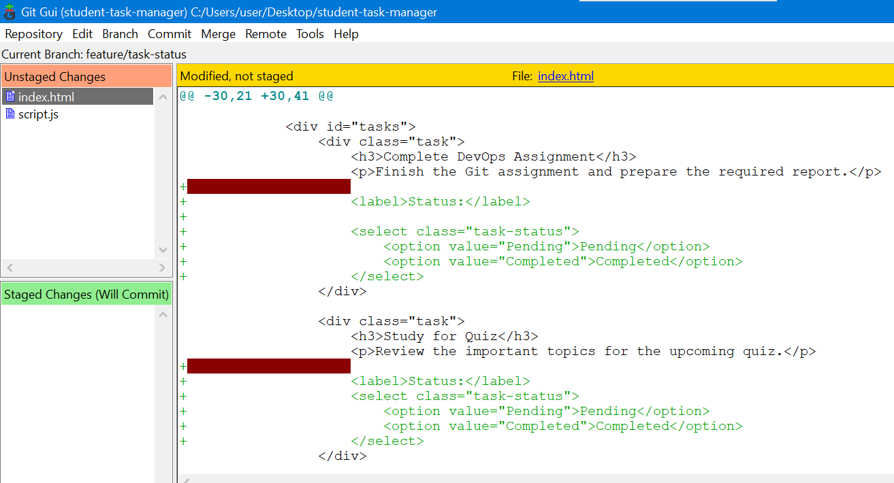
17. Commit of the Task Status Feature:
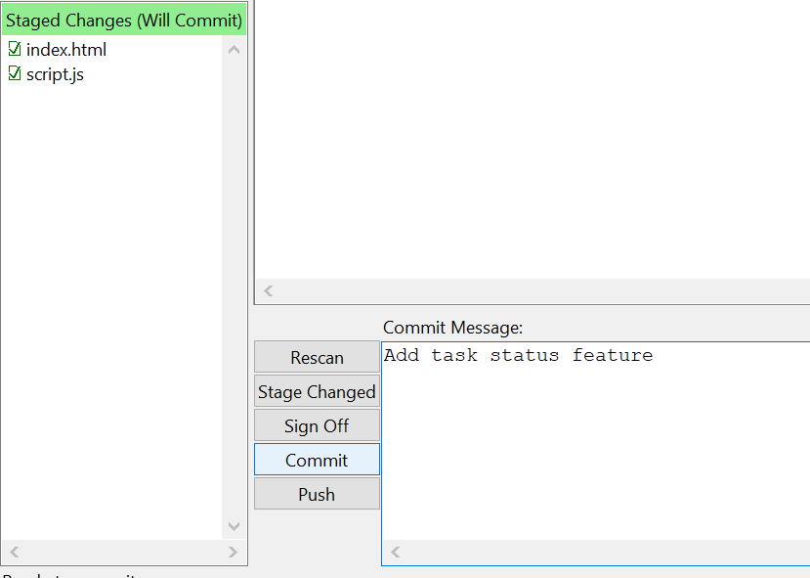
18. Git History Showing Successful Third Commit:
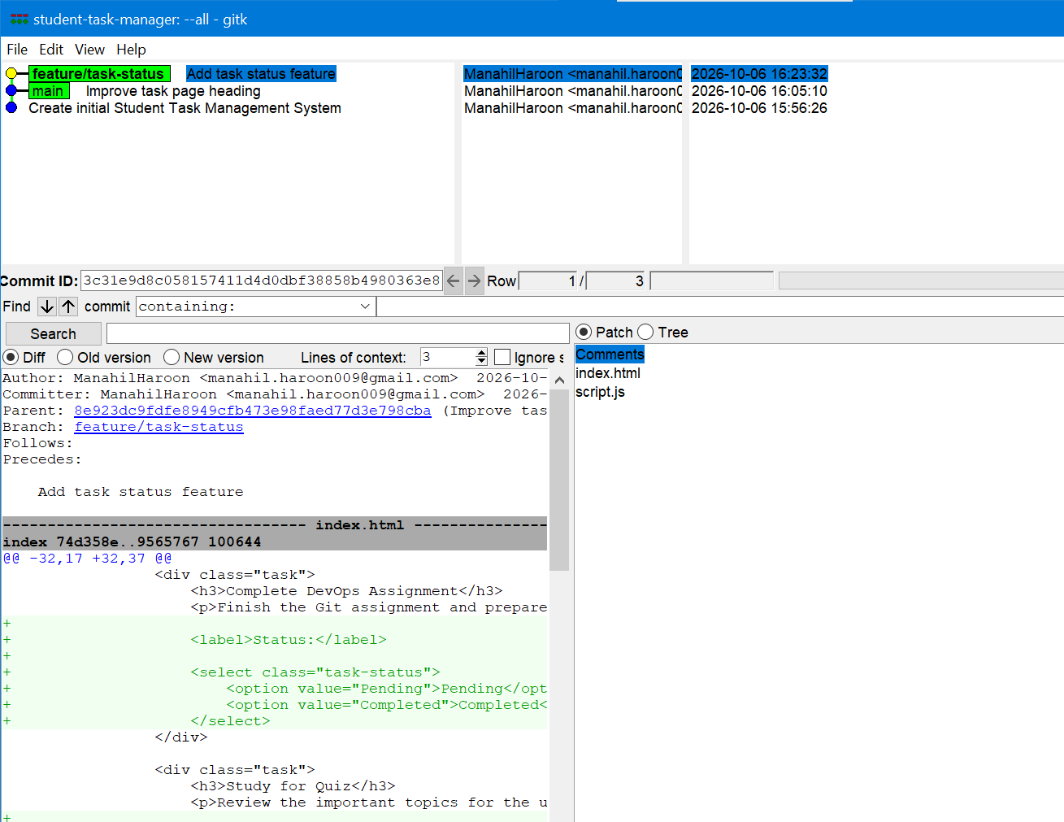
Task 6 – Demonstrate Branch Isolation
19. Checkout of the Main Branch:
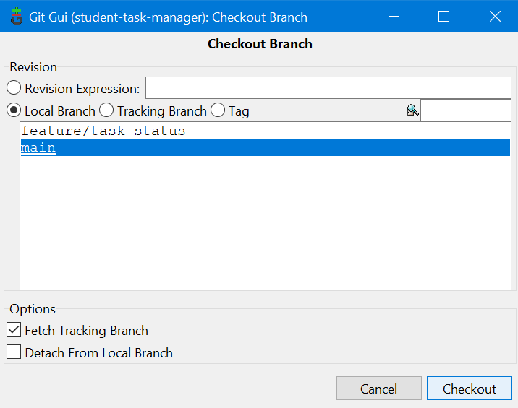
20. Main Branch Before Feature Merge (Branch Isolation):


Task 7 – Merge the Feature into Main
21. Merging the Feature Branch into the Main Branch: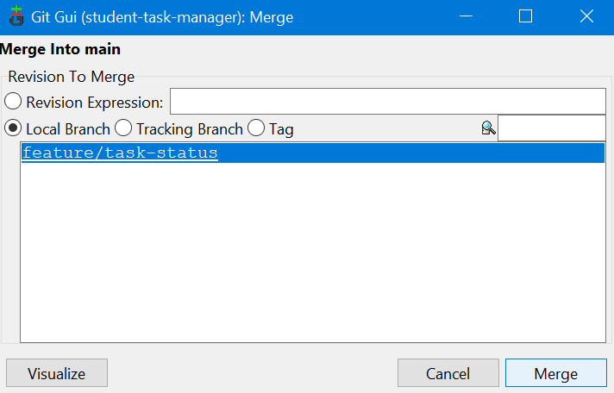
22. Successful Feature Branch Merge: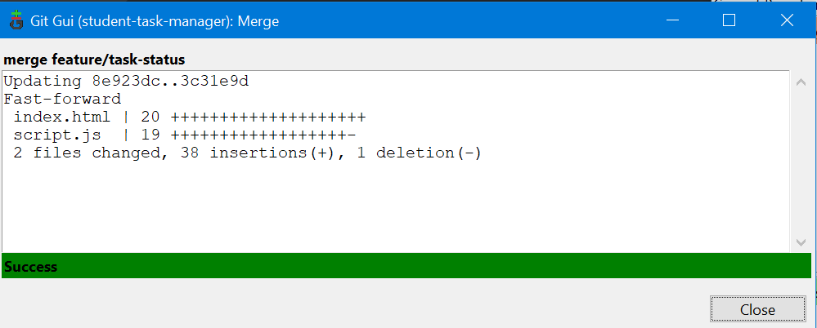
23. Task Status Feature Available on the Main Branch After Merge: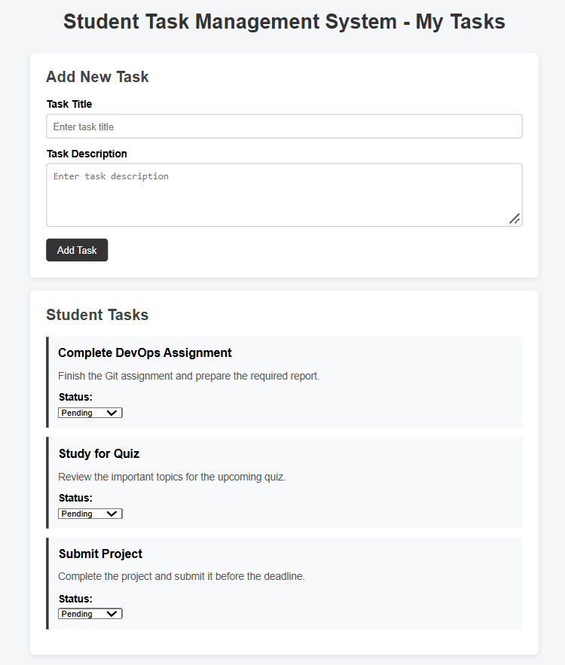
24. Final Git History Verification:
